**Bank Churn Analysis**

**Database Used**: Microsoft SQL Server

**Project Summary**

This project focuses on analyzing bank customer data to extract actionable insights related to financial behavior, credit usage, income patterns, and risk profiling. Rather than directly targeting churn prediction, the analysis emphasizes overall customer profiling and banking performance metrics.

The project falls under the **Banking and Financial Analytics domain**, where large volumes of customer transaction data, credit history, and spending behavior are analyzed to support data-driven decision-making across various banking functions.

**Objectives & Key Focus Areas**

* Perform customer segmentation based on **age, income, education**, and **credit behavior**
* Analyze **credit utilization patterns** and assess **financial risk levels**
* Understand customer **spending behavior and financial health**
* Identify **high-value customers** and **dormant or high-risk accounts**
* Enable banks to personalize services and optimize marketing strategies

**Techniques Used**

Using SQL Server, a series of queries were executed to generate **Key Performance Indicators (KPIs)** and **insightful breakdowns** of customer profiles. This data can support strategic decisions in customer engagement, financial risk management, and service delivery.

**Business Applications**

* 🔍 **Improved Credit Risk Management**: Identify customers with high utilization or low repayment capacity
* 👤 **Targeted Banking Services**: Recognize and serve high-net-worth individuals more effectively
* 📈 **Optimized Marketing**: Focus campaigns on customer segments with high revenue potential
* 🔄 **Customer Retention**: Detect inactivity in customer accounts and implement re-engagement strategies

**KPI’s Requirements:**

**1.Total number of customers**

**SELECT COUNT(clientnum) AS Total_Customers FROM [dbo].[bank_churn_data];**

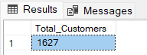

**2. Average credit utilization ratio**

**SELECT ROUND(AVG(utilization_ratio), 2) AS Avg_Utilization FROM [dbo].[bank_churn_data];**

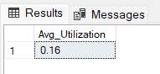

**3. Average credit limit**

**SELECT ROUND(AVG(credit_limit), 2) AS Avg_Credit_Limit FROM [dbo].[bank_churn_data];**

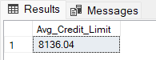

**4. Average customer age**

**SELECT AVG(customer_age) AS Avg_Customer_Age FROM [dbo].[bank_churn_data];**

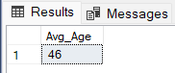

**Deep-Dive Insights :-**

**1. Customer Distribution by Card Category**

**SELECT card_category, COUNT(clientnum) AS Customer_Count**

**FROM [dbo].[bank_churn_data]**

**GROUP BY card_category**

**ORDER BY Customer_Count DESC;**

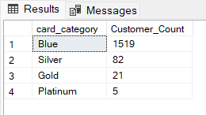

**2. Average Balance by Income Level**

**SELECT income, AVG(balance) AS Avg_Balance**

**FROM [dbo].[bank_churn_data]**

**GROUP BY income**

**ORDER BY Avg_Balance DESC;**

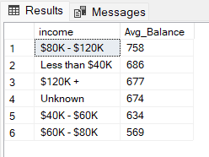

**3. Customer Count by Marital Status**

**SELECT marital_status, COUNT(clientnum) AS Customer_Count**

**FROM [dbo].[bank_churn_data]**

**GROUP BY marital_status**

**ORDER BY Customer_Count DESC;**

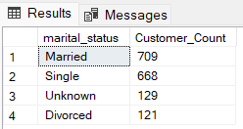

**4. Customer Segmentation by Age Group**

**SELECT**

**CASE**

**WHEN customer_age BETWEEN 18 AND 25 THEN '18-25'**

**WHEN customer_age BETWEEN 26 AND 35 THEN '26-35'**

**WHEN customer_age BETWEEN 36 AND 45 THEN '36-45'**

**WHEN customer_age BETWEEN 46 AND 55 THEN '46-55'**

**ELSE '56+'**

**END AS Age_Group,**

**COUNT(clientnum) AS Total_Customers**

**FROM [dbo].[bank_churn_data]**

**GROUP BY CASE**

**WHEN customer_age BETWEEN 18 AND 25 THEN '18-25'**

**WHEN customer_age BETWEEN 26 AND 35 THEN '26-35'**

**WHEN customer_age BETWEEN 36 AND 45 THEN '36-45'**

**WHEN customer_age BETWEEN 46 AND 55 THEN '46-55'**

**ELSE '56+'**

**END**

**ORDER BY Total_Customers DESC;**

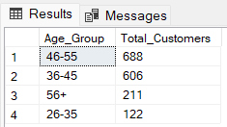

**5. Top 10 Customers by Credit Utilization**

**SELECT TOP 10 clientnum, customer_age, income, credit_limit, utilization_ratio**

**FROM [dbo].[bank_churn_data]**

**ORDER BY utilization_ratio DESC;**

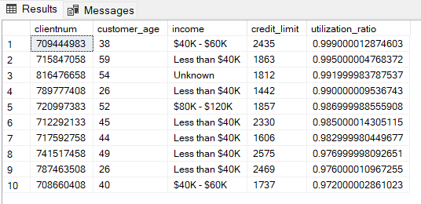

**6. High Credit Limit but Low Balance Customers**

**SELECT TOP 10 clientnum, customer_age, income, credit_limit, balance,**

**ROUND((balance * 100.0 / credit_limit), 2) AS Balance_Percentage**

**FROM [dbo].[bank_churn_data]**

**WHERE balance < (0.2 * credit_limit)**

**ORDER BY Balance_Percentage;**

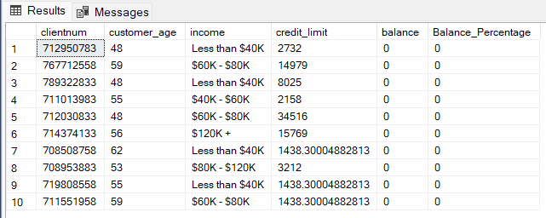

**7. Top 10 Longest Tenure Customers**

**SELECT TOP 10 clientnum, customer_age, months_on_book, income, balance**

**FROM [dbo].[bank_churn_data]**

**ORDER BY months_on_book DESC;**

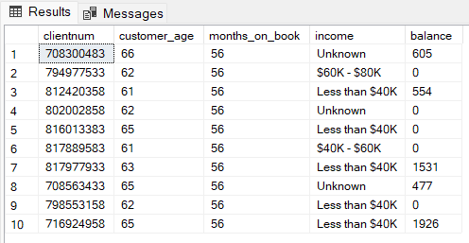

**8. Average Number of Dependents by Income Group**

**SELECT income, ROUND(AVG(dependent_count), 2) AS Avg_Dependents**

**FROM [dbo].[bank_churn_data]**

**GROUP BY income**

**ORDER BY Avg_Dependents DESC;**

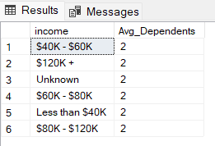

**9. Credit Utilization Risk Assessment**

**SELECT clientnum, customer_age, income, credit_limit, utilization_ratio,**

**ROUND((utilization_ratio * 100.0), 2) AS Utilization_Percentage,**

**CASE**

**WHEN utilization_ratio > 0.8 THEN 'High Risk'**

**WHEN utilization_ratio BETWEEN 0.5 AND 0.8 THEN 'Moderate Risk'**

**ELSE 'Low Risk'**

**END AS Risk_Level**

**FROM [dbo].[bank_churn_data]**

**ORDER BY utilization_ratio DESC;**

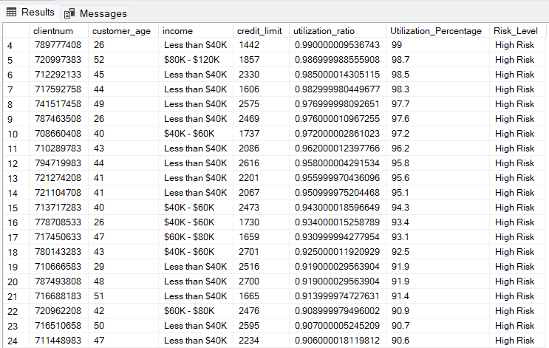

**10. VIP Customers (Tenure > 53 Months)**

**SELECT clientnum, customer_age, months_on_book, income, balance, credit_limit**

**FROM [dbo].[bank_churn_data]**

**WHERE months_on_book > 53**

**ORDER BY balance DESC;**

